ANALYSIS OF CELLULAR FREQUENCY PLANNING AND HANDOVER PERFORMANCE UNDER USER MOBILITY CONDITIONS USING MATLAB
Analog and Digital Communication — Experiment 30
Date of Experiment | 12/10/2026
Performed By | Lokesh A
Register Number | 192512293
1. Aim
To analyze cellular frequency planning and handover performance under user mobility conditions using MATLAB by assigning a moving user to the nearest of three cell centers and plotting the selected cell and cell locations.
2. MATLAB Program
clc;
clear;
close all;
% Cell Centers (3 Cells)
cellPos = [0 500 1000];
% User Movement
user = 0:10:1000;
% Nearest Cell Selection (Handover)
handover = zeros(size(user));
for i = 1:length(user)
[~,handover(i)] = min(abs(user(i)-cellPos));
end
% Display
disp('User Position Connected Cell')
disp([user' handover'])
% Plot
figure;
subplot(2,1,1)
plot(user,handover,'b','LineWidth',2)
title('Handover Performance')
xlabel('User Position (m)')
ylabel('Cell Number')
grid on
subplot(2,1,2)
stem(cellPos,[1 2 3],'filled')
hold on
plot(user,ones(size(user))*2,'r--')
title('Cellular Frequency Planning')
xlabel('Distance (m)')
ylabel('Cell')
grid on
3. Output
The Command Window lists each user position and its connected cell. The first plot shows the selected cell as the user moves from 0 m to 1000 m. The second plot marks the three cell centers and includes the horizontal reference line at Cell 2, as specified in the MATLAB code.
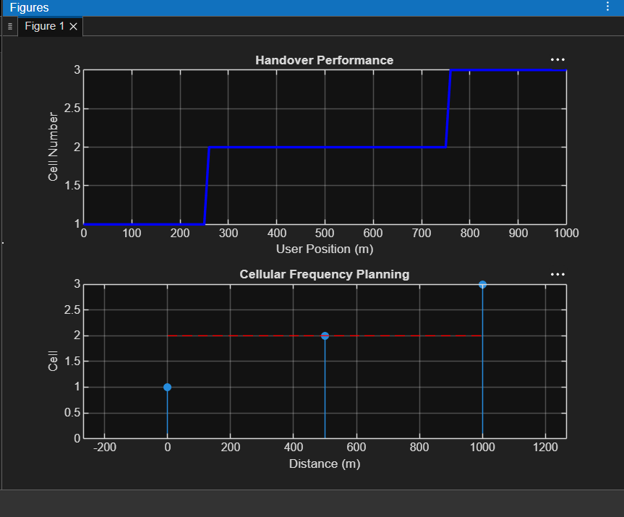
Figure 1: MATLAB output showing handover performance and cellular frequency planning.
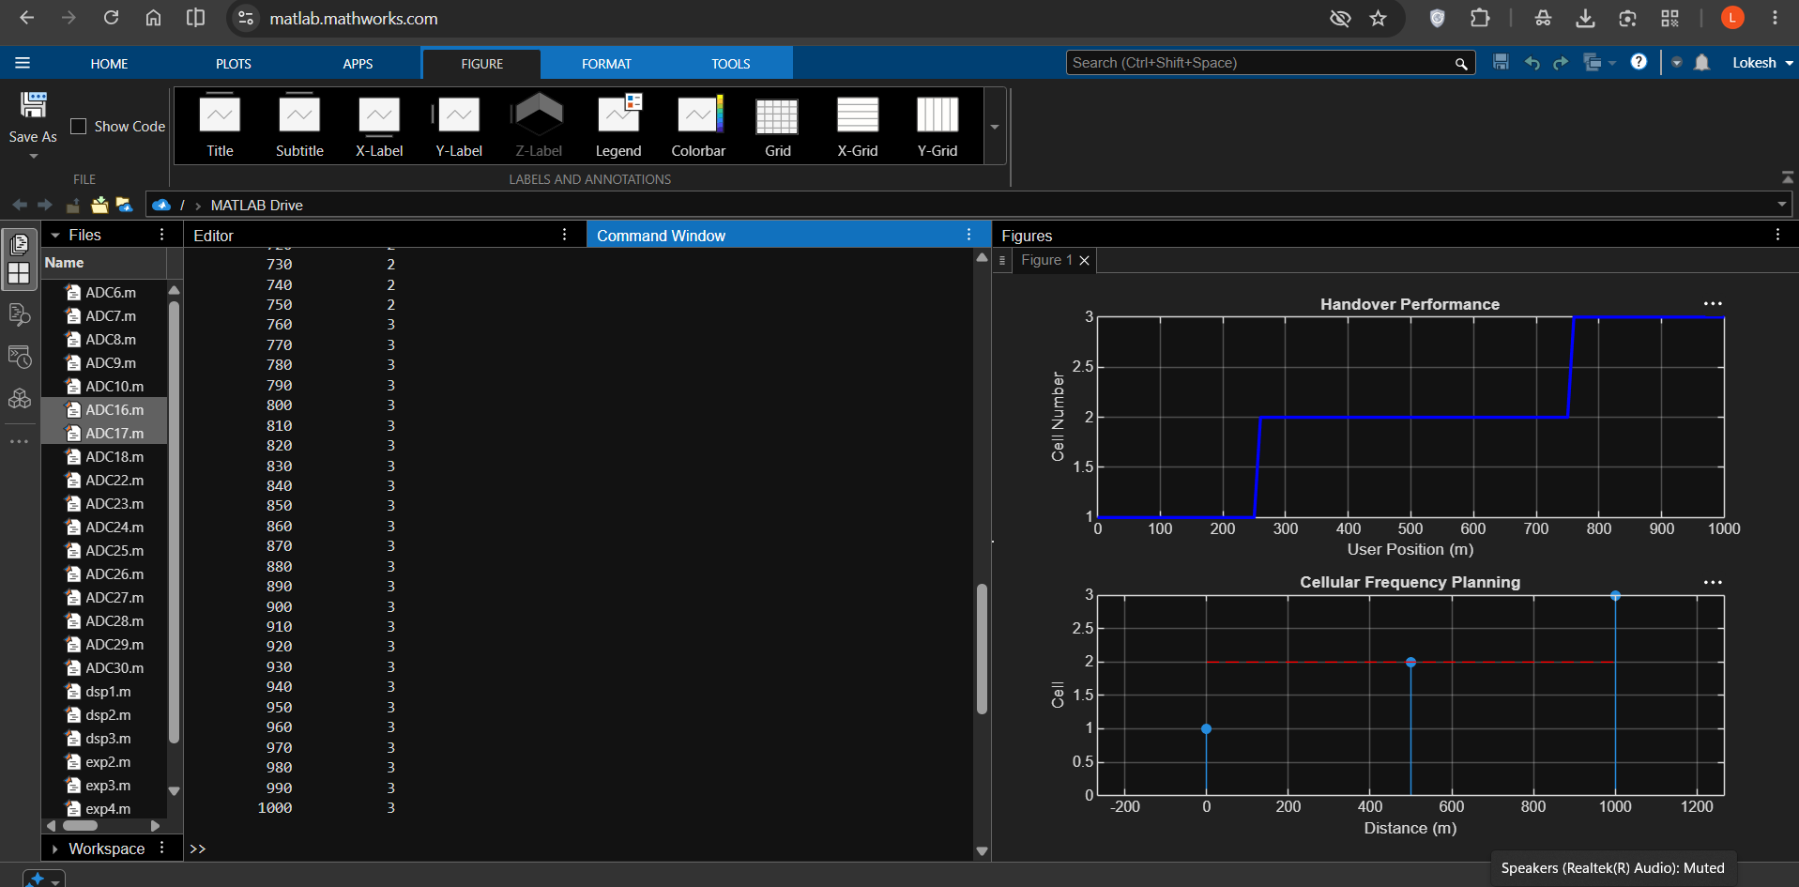
Figure 2: Enlarged plots of handover performance and cellular frequency planning.
4. Simulation Parameters
Parameter | Value
Number of cells | 3
Cell centers | 0 m, 500 m, 1000 m
User position range | 0 m to 1000 m
User position increment | 10 m
Cell selection method | Nearest cell center
Number of user positions | 101
5. Procedure
- Clear the MATLAB workspace and close all existing figures.
- Define the positions of the three cell centers as 0 m, 500 m and 1000 m.
- Generate user positions from 0 m to 1000 m in increments of 10 m.
- For each user position, calculate the distance to every cell center and select the nearest cell.
- Display the user positions and connected-cell numbers in the Command Window.
- Plot the handover performance and the cellular frequency planning graph.
6. Applications
- Illustrating cell selection as a mobile user moves through a cellular network.
- Studying the basic concept of handover between neighboring cells.
- Visualizing cell locations and user mobility in cellular communication.
7. Result and Discussion
The simulation assigns each user position to the nearest cell center and displays the connected cell number. The handover plot changes from Cell 1 to Cell 2 and then to Cell 3 as the user moves across the defined positions. The second plot displays the cell centers and the reference line included in the program.
8. Conclusion
The MATLAB program demonstrated nearest-cell selection for a moving user in a three-cell network and visualized the resulting handover behavior. The plots help illustrate the relationship between user position, cell location and connected-cell selection.
DONE BY
Lokesh A
Register Number: 192512293
B.E. Electronics and Communication Engineering (ECE)

